Understanding Simple Linear Regression
- Simple Linear Regression is one of the most fundamental algorithms in machine learning.
- It helps us predict the value of one variable (the dependent variable) based on another variable (the independent variable).

The Simple Linear Regression Equation
The equation for simple linear regression is:
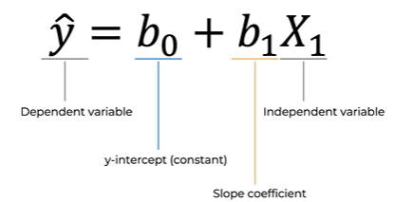
Where:
- Y = Dependent variable (the value we want to predict)
- X = Independent variable (the predictor)
- b₀ = Intercept (or constant), representing the value of Y when X = 0
- b₁ = Slope coefficient, indicating how much Y changes for every one-unit increase in X

Example: Predicting Potato Yield
- Let's understand this concept with a practical example.
- Suppose a farmer wants to predict the potato yield based on the amount of nitrogen fertilizer used.
- The regression equation becomes:
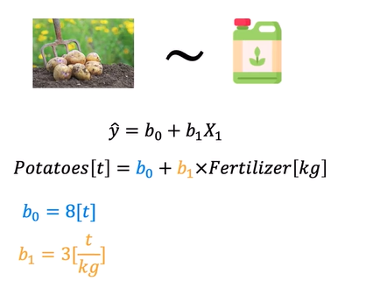
After training the regression model on historical farm data, we obtain:
- Intercept (b₀) = 8 tons
- Slope (b₁) = 3 tons per kilogram
So the equation becomes:

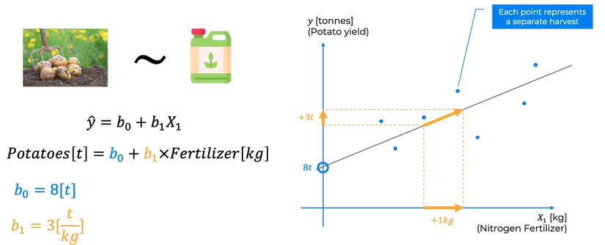

What Do These Values Mean?
- Intercept (b₀ = 8)
The intercept represents the predicted potato yield when no fertilizer is used.
- If fertilizer = 0 kg
- Predicted potato yield = 8 tons
This is where the regression line crosses the Y-axis.

Slope (b₁ = 3)
- The slope tells us how the potato yield changes with fertilizer usage.
A slope of 3 means:
- For every additional 1 kilogram of nitrogen fertilizer applied, the predicted potato yield increases by 3 tons.
- This indicates a positive relationship between fertilizer usage and potato production.

Visual Interpretation
Imagine plotting the data on a graph:
- X-axis: Nitrogen fertilizer used (kg)
- Y-axis: Potato yield (tons)
Each point on the scatter plot represents a different harvest season. Over several years, the farmer recorded:
- How much fertilizer was applied
- How many tons of potatoes were harvested
These observations form a collection of data points.
The linear regression algorithm then fits the best-fit straight line through these points.
- The line starts at the Y-intercept (8 tons).
- It rises with a slope of 3, meaning the predicted yield increases by 3 tons for every additional kilogram of fertilizer.
The line summarizes the overall relationship between fertilizer use and potato production.
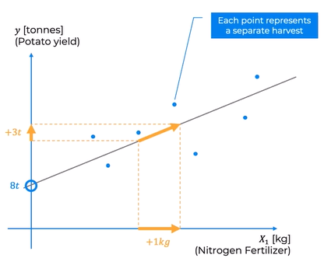

Key Takeaways
- Simple Linear Regression predicts one variable using another.
- The dependent variable (Y) is the value being predicted.
- The independent variable (X) is the predictor.
- The intercept (b₀) is the predicted value of Y when X is zero.
- The slope (b₁) shows how much Y changes for each one-unit increase in X.
- A scatter plot visualizes the data, while the regression line represents the best linear relationship between the variables.
Note: The numerical values used in this example (8 tons and 3 tons per kilogram) are hypothetical and are intended solely to illustrate the concept of simple linear regression.

Summary
Simple Linear Regression models the relationship between two variables using a straight line. By estimating the intercept and slope, the model can make predictions and help us understand how changes in the independent variable influence the dependent variable. In our potato farming example, the model predicts potato yield based on the amount of nitrogen fertilizer applied, providing a simple yet powerful way to analyze and forecast outcomes.

Ordinary Least Squares (OLS): Finding the Best Regression Line
- When working with Simple Linear Regression, one important question arises:
- How do we determine which regression line best fits the data?
- Since multiple straight lines can be drawn through the same set of data points, we need a systematic way to identify the one that provides the most accurate predictions. This is where the Ordinary Least Squares (OLS) method comes into play.

Why Do We Need Ordinary Least Squares?
- Imagine a scatter plot representing historical data. For example:
- X-axis: Nitrogen fertilizer used (kg)
- Y-axis: Potato yield (tons)
- Several straight lines could potentially fit these data points. Some may be steeper, others flatter, and each one produces different predictions.
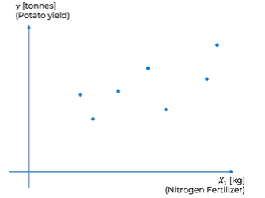
The challenge is to determine:
- Which line represents the data most accurately?
- How do we define the "best" fit?
- The Ordinary Least Squares (OLS) method provides the answer by measuring how well each candidate line predicts the observed data.

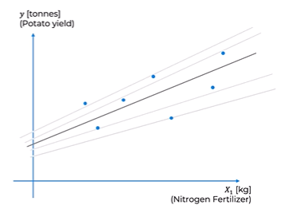

Understanding Actual vs. Predicted Values
- For every observation in the dataset, there are two important values:
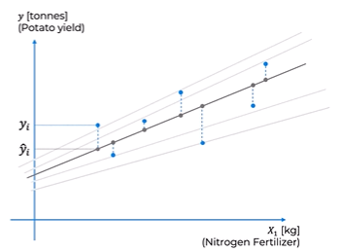

1. Actual Value (yiy_iyi​)
- This is the real value observed in the dataset.
For example:
- Fertilizer used = 15 kg
- Actual potato yield = 2 tons
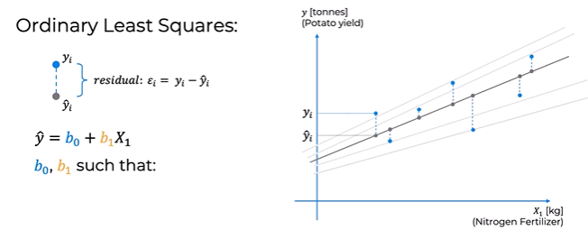

2. Predicted Value (y^i\hat{y}_iy^​i​)
The regression line predicts what the yield should be for the same fertilizer amount.
For example:
- Fertilizer used = 15 kg
- Predicted potato yield = 1.5 tons
This predicted value is represented by
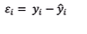

What Is a Residual?
The difference between the actual value and the predicted value is called the residual (or prediction error).

Using our example:
- Actual yield = 2 tons
- Predicted yield = 1.5 tons
Residual:
2−1.5=0.5 tons2 - 1.5 = 0.5 \text{ tons}2−1.5=0.5 tons
A residual indicates how far the prediction is from the actual observation.

Visual Interpretation
On a scatter plot:
- Each point represents an actual observation.
- The regression line provides predicted values.
- The vertical distance between a data point and the regression line represents the residual.
Some points lie above the line, while others lie below it. Therefore, every observation has its own residual.
It is nearly impossible for a single straight line to pass through every data point perfectly, especially in real-world datasets. Instead, the goal is to find the line that minimizes these prediction errors.

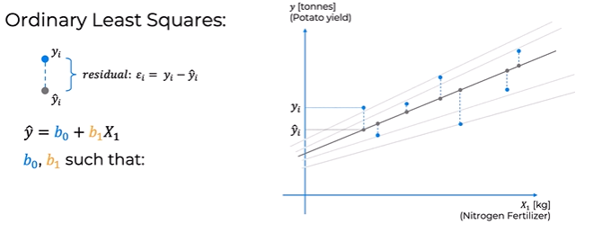

Why Are Residuals Squared?
If we simply added all residuals together, positive and negative errors would cancel each other out.
To avoid this problem, OLS squares each residual before summing them.
The objective is to minimize:
∑(yi−y^i)2\sum (y_i - \hat{y}_i)^2∑(yi​−y^​i​)2
This quantity is known as the Sum of Squared Residuals (SSR) or Residual Sum of Squares (RSS).
Squaring the residuals offers two key advantages:
- It eliminates negative values, preventing errors from canceling each other.
- It penalizes larger errors more heavily, encouraging the model to fit the data as closely as possible.

The Ordinary Least Squares (OLS) Objective
The regression model contains two unknown parameters:
- b0b_0b0​ – Intercept
- b1b_1b1​ – Slope
The Ordinary Least Squares method searches for the values of b0b_0b0​ and b1b_1b1​ that produce the smallest possible Sum of Squared Residuals.
Mathematically,
min⁡∑i=1n(yi−y^i)2\min \sum_{i=1}^{n}(y_i-\hat{y}_i)^2mini=1∑n​(yi​−y^​i​)2
The regression line with the lowest total squared error is considered the best-fit line.

Why Is It Called "Least Squares"?
The name comes directly from the optimization process:
- Least → We want the smallest possible error.
- Squares → Errors (residuals) are squared before being added together.
Hence, the method is called Ordinary Least Squares (OLS).

Example
Suppose we compare three different regression lines for the same dataset.
Regression Line | Sum of Squared Residuals
Line A | 58
Line B | 31
Line C | 45
Since Line B has the smallest Sum of Squared Residuals, it is selected as the best regression line.

Key Takeaways
- Multiple regression lines can fit the same dataset.
- The Ordinary Least Squares (OLS) method identifies the best-fitting line.
- Each observation has:
  - Actual value (yiy_iyi​)
  - Predicted value (y^i\hat{y}_iy^​i​)
- The difference between them is called the residual.
- OLS minimizes the Sum of Squared Residuals (SSR/RSS).
- Squaring residuals prevents positive and negative errors from canceling each other and gives greater importance to larger errors.
- The regression line with the smallest total squared error is considered the optimal model.
